Game Pitch

EXACT ENGINES

Joseph Rizzuto, Isaiah Majeed, Damon Anderson, Samari Oglesby

08/31/2024

Version 1.0

**Table of Contents**

**Executive Summary**

**High Concept**

**Features and Synopsis**

**Play Motivation**

Genre, Platform, and ESRB

Audience and Targeted Customers

Threats and Competition

**Game Differentiators/Unique Selling Points**

**Overall Game Design**

**Game Aesthetic**

**Gameplay Board: Game Core Mechanics**

# Executive Summary

## High Concept

- Escaping a dungeon full of traps

- Getting through the levels as fast as you can

## Features and Synopsis

- Player starts in middle of each dungeon, can go left or right

- Player has to dodge traps and enemies

- Health system and player takes damage when hitting traps and enemies

- Minor platforming elements (jumping over lava, and avoiding enemies)

- Puzzle solving elements – Pushing boxes and getting keys for doors

- Scoring system for collectibles and beating the level faster (there is a timer for each level)

- Player has to get to end of dungeon to beat each level

- Ending screen when all levels are completed

## Play Motivation

- Escape the dungeon

- Don’t lose all your health and die

- Playing faster will get you a better score

- Completing puzzles should feel satisfying

### Genre, Platform, and ESRB

Genre: 2D puzzle game with light platforming elements

Platform: PC/Web

Expected ESRB: E for Everyone

### Audience and Targeted Customers

Game is intended for people who like puzzles where you have to escape a room full of dangers. Slight skill required to not die to traps/enemies, and intuition to solve the puzzles

### Threats and Competition

* Platforming Games (Mario)
* Puzzle Games

## Game Differentiators/Unique Selling Points

* It feels like an escape room, but deadly
* Dungeon aesthetic is focused on in this game. Since it’s the only place in the setting of the game, it can be focused on, unlike other games
* Atmosphere and art will feel futuristic like the Portal series, except in 2D
* Comedic story – player character gets stuck in a dungeon because they opened the wrong door (thought it was the bathroom), and now have to escape. Most escape room games on the web don’t have any story.

# Overall Game Design

## Game Aesthetic

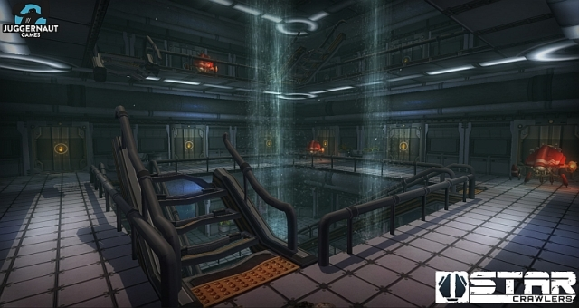

## Gameplay Board: Game Core Mechanics

